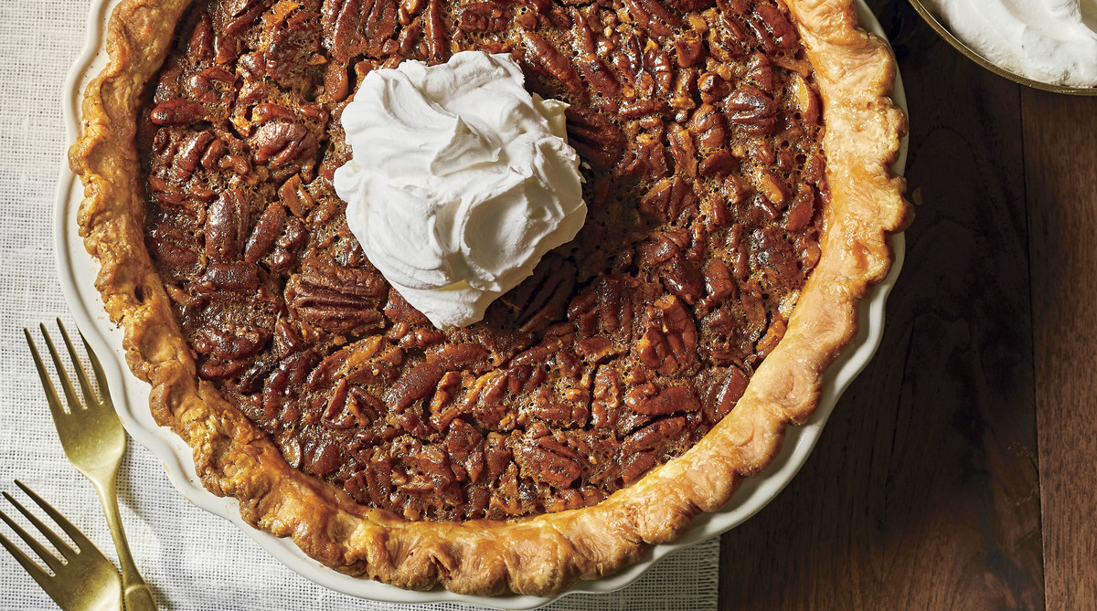

Pecan Pie!!!!!!!!!!!!